7v7 Soccer Rules for the U10 Division
RULES OF THE GAME
(Updated 8/1/16)

Field Dimensions: The playing field is 45-60 yards in length, and 35-45 yards wide. The goals are 6’h x 12’w.

Ball Size: The Ball: must be a size four. The smaller ball is lighter and more easily kicked, received, dribbled and passed.

Offside in 6v6. The Offside law will be observed in the U10. However, if only a center referee is available, offside will not be called unless it is obvious. However, the coaches should adhere to the spirit of the offside law and not allow a player to “hang out” on top of the goal box. Continued abuse of the law will result in a warning.

Number of Players: Each team can have seven players on the field. However, a team may start with a minimum of six players, but each team would need to play equal strength.

Duration of the Game: Each game will consist of two 25 minutes halves, with a 5 minutes half-time.

Rules of the Goal Keeper: In the U9/U10 age groups the goalkeeper may (see attached sheet): (1) Goal Kicks still must land on the goalies own half before rolling over the halfway line; (2) Throw the ball past midfield in the air; (3) Roll the ball past midfield; (4) Place the ball down on the ground and kick it past midfield in the air. In the 9U/10U age groups the goalkeeper may not drop-kick or punt the ball. The goalkeeper must roll or throw the ball once they stop it, catch it or pick it up with their hands. A deflection does not count as a possession with the Goalie’s hands.

If the goalie punts the ball, it is an indirect kick from the spot where the goalie kicked the ball. If the goalie touches the ball again after throwing/rolling but before anyone else on the field, the foul is an indirect kick at the spot where the Goalie touched it with his/her foot.

The 6 second goalie release will not apply until every defender crosses behind the Build Out Line.

Throw-ins: A throw-in is awarded when a ball is kicked out from the sideline. (Retries are NOT allowed.)

Goal Kicks: Goal kicks are placed anywhere in the goal box, and must be kicked out of the penalty box before another player touches it.

Headers: In accordance with the US Soccer’s Safety initiative beginning in 2016, deliberate headers are NOT allowed in the 10U division or any younger division. If a player deliberately heads the ball, an indirect free kick will be awards at the spot of the header.
Build-Out Lines: There is a new line that is 14 yards parallel from the goal line and it painted all the way across the field. It is called the Build-Out Line. The purpose of this line is to give the offense a chance to build play out of the back (defensive half of the field). Since the goalkeeper cannot punt, this will give the offense a chance to possess the ball cleanly before being challenged by the defense.
The defense must move back beyond this line once the goalie gets possession. This goes for both goal kicks and when the goalie stops the ball during play (and has to roll/throw it). The defense cannot cross the Build Out line until the goalie puts the ball into play by releasing it. If the defense does not move behind the build-out line and interferes with play, then the foul is an indirect kick where the defense touched the ball in the area between the goal line and the build-out line.
The goalkeeper does not have to wait until all of the defenders have moved behind the build-out line to put the ball in play. It is the goalie’s option. If a defender interferes or touches the ball before the defender crossed the build-out line, it is still an indirect free kick awarded to the Goalie’s team.
Free Kicks: The distance the defending players must be away from the ball until it is kicked is the same as the radius of the center circle.

Penalty Kick: The penalty mark is eight yards from the center of the goal line and those players other than the kicker and defending goalkeeper are at least eight yards from the penalty mark. The distance of eight yards conforms to the radius of the center circle. The distance of eight yards from the center of the goalmouth for the penalty mark fits within the reduced dimensions of the penalty area and is a reasonable distance for the kick.

Corner Kick: The distance the defending players must be away from the ball until it is kicked is the same as the radius of the center circle.

Hand Ball Clarification: Deliberate handling of the ball that denies the opposing team a goal or an obvious goal scoring opportunity will result in the following: a free kick according to the FIFA rules.
No Heading: In accordance with U.S. Soccer and Indiana Soccer, heading is eliminated for children 10 and under due to the possibility of a concussion. When a player deliberately heads the ball in a game, an indirect free kick (IFK) should be awarded to the opposing team from the spot of the offense. If a player does not deliberately head the ball, then play should continue.
Referee: A center referee will be assigned to each U10 game. Assistant Referees may be used during the game, but are not mandatory. Coaches and assistant coaches should remain on the side-line and not enter the field of play during a game unless called on by the referee.
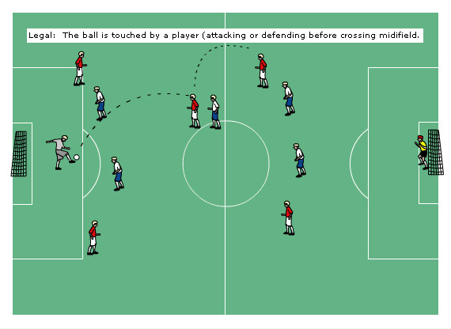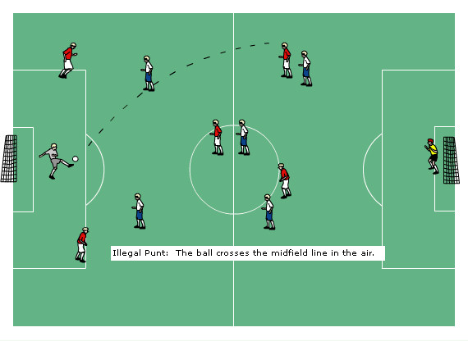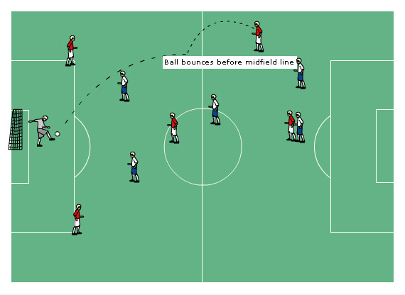

Illustration of U10 Punt Rule

In the U9/U10 age groups the goalkeeper may:
- Kick the ball past midfield on a goal kick.
- Throw the ball past midfield in the air.
- Roll the ball past midfield.
- Place the ball down on the ground and kick it past midfield in the air.
- Drop kick the ball past midfield in the air.
- Punt the ball but it must land in their own defensive half before crossing the midfield line.

Legal Punt Diagram 1

The ball bounces on the ground and goes
past midfield.
Legal Punt Diagram 2

The ball is touched by a player (attacker or defender) before crossing midfield.
Illegal Punt Diagram

In the U9/U10 age groups the goalkeeper may NOT:

Punt the ball past midfield in the air.

An infraction will result in an indirect free kick from the midfield line for the opposing team.

