General Soccer Rules for ALL Divisions

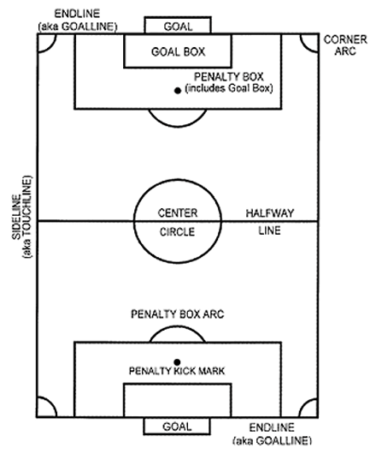
Soccer is one of the simplest sports in the world. This may be the reason why it's the most popular sport in the world. Here you will find the rules to play the game. The rules become more complicated and technical with the level of play. But even at the professional level they are quite simple.

KICK-OFFS: The game is started at each half or following a goal at the center of the field. The team who kicks off passes the ball forward to a teammate at the referees signal.

- Players must be in their own half of the field – the side that the team is defending.
- The kicking team may have any number of players in the center circle. However, usually, you have two people in the middle at the ball, while two other players on each side of the field ready to receive the ball or run forward when the ball is kicked.
- The opposing team, though, is not allowed to enter the center circle until the team kicks off.
- The kick MUST go forward. (If it goes backwards, the team re-kicks the ball.)
- The kicker can only kick the ball once. (If a kicker kicks the ball twice, the team re-kicks the ball.)
- For U4, U6 & U8, it is best to teach the one player to kick the ball forward, but to the side, to a teammate. Kicking the ball forward into the opposing team doesn’t do much.
- For U10 & up have two players kick off, alternating different types of kick-offs:
  - One player kicks it forward a little then runs forward; while the second player kicks the ball forward to an empty space near his teammate.
  - One player kicks it forward a little then runs forward; while the second player kicks the ball to either side to a teammate.
  - One player kicks it forward a little then runs forward; while the second player passes the ball back to a defender.
  - Remember, kicking the ball down field to the other team doesn’t do anything for your team.

GAME IN PLAY:

The play continues as long the ball stay in the field the game is in play or if the referee blows the whistle for an infraction. The ball is considered in play as long as it is in side the goal and side lines. Furthermore, it's still in play as long as it has contact with the line. Therefore, the ball may be touching the outer part of the goal or side line and still be considered in play (This applies if the ball is in the air as well). contact with the goal post, corner flag, and referee back in the field is still considered in play. The referee is considered a fixture of the field.
GOAL:

In the basic soccer rules the point of the game is to get the ball in the opposing teams goal and the team with the most goals after the specified time is the winner. The ball must cross the goal line to be a goal. Therefore, if the ball is still in contact with the goal line in the inner part of the goal it is not a goal!

- You cannot score directly on a throw-in, but must touch another player before going in.
- You cannot score directly on a drop-kick, but must touch another player before going in.
- You can score directly on a kick-off. However, in our Rec division, we do not recommend this because our objective is to increase skill and teamwork.

THROW-INS: If the ball goes out along the touchline or sideline, a throw-in is awarded to the opposite team that touched the ball last.

- The ball must be thrown with both hands.
- It must be thrown from behind the head.
- The player making a throw-in must have both feet on the ground when throwing the ball.
- He may run to gain momentum for the throw-in but both his feet should be on the ground when the ball is released.
- He must stay off the field of play, though he may step on the line when making the throw.
- He can only touch the ball again after it has been played by another player.
- Players must be at least two meters away from the thrower before the ball is released.
- A goal cannot be scored directly from a throw-in. It must be touched first by another player.
- If a player throws the ball into the opponents’ goal, play will be restarted by a goal kick from the opposing team’s end.
- If the throwing player puts the ball into his own team’s goal, play will be restarted with a corner kick for the opposing team.
- A player cannot be offside in football when receiving a throw-in.
GOAL KICK: A goal kick is awarded when the offensive team plays the ball out of bounds over the defensive team’s goal line.

- After the ball is out of play, the defender or goalkeeper may place the ball anywhere within the six-yard goal box and kick the ball back into play.
- The ball MUST come out of the penalty area before any other player touches the ball. (If the ball doesn’t make it outside of the penalty area, the goal kick is retaken.)
- Players may be in the penalty area when the ball is kicked, but cannot touch the ball until it goes outside of the penalty box. (If a player touches the ball before it comes out of the penalty box, the goal kick is retaken.)
- Build-Out Lines: When a goalie is used a build out line will be implemented. A build out line is used to promote playing the ball out of the back in an unpressured setting. When the goalkeeper has the ball, either during play or from a goal kick, the opposing team must move behind the build out line. Once the opposing team is behind the build out line, the goalkeeper can pass, throw or roll the ball to a teammate. Punting the ball is not allowed as this would defeat the purpose of the build out line and reduces the opportunity to play out of the back in an unpressured setting. After the ball is put into play, the opposing team can then cross the build out line and play can resume as normal.

CORNER KICK: A corner kick is awarded to the offensive team when the defensive team plays the ball out of bounds over its goal line. The ball is placed within the corner area and is kicked back into play by the offensive team. Players can score directly off a corner kick.

- The ball can be placed anywhere in the corner arc.
- Players must stand at least 3 yards away from the arc.
- The player kicking the ball may not touch the ball again until it has been touched by another player on the field.

DROP BALL: A drop ball is played when the referee stops play for a reason other than a rule infraction such as an injury.

- The referee restarts play by dropping the ball between two players, one from each team.
- A dropped ball may not be played until it touches the ground.
- The first player playing the ball is allowed to play the ball again without it having to be touched by another player. This means the player may dribble, pass or shoot the ball after touching it.
- A player cannot kick the ball directly into the goal from a drop kick. Ball must touch another player before entering goal.

SPECIAL GOALIE RULES:

- The goalie can handle the ball anywhere within the penalty area. If the goalie handles the ball outside the penalty area, the penalty is an indirect kick.
- The goalie, though, cannot handle the ball if the ball is kicked to him/her directly from a teammate. (Penalty: indirect free kick)
- The goalie should go all the way up to the edge of the penalty area before throwing or kicking the ball.
HEADING THE BALL: In accordance with U.S. Soccer and Indiana Soccer, heading is eliminated for children 10 and under due to the possibility of a concussion. When a player deliberately heads the ball in a game, an indirect free kick (IFK) should be awarded to the opposing team from the spot of the offense. If a player does not deliberately head the ball, then play should continue. For children 11 and older, the coach should teach the proper technique, but limit the amount of heading in practices.

